**Gebze Technical University**

**Computer Engineering**

**Computer Graphics(CSE 461)**

**Homework #1**

**Berkan AKIN**

**171044073**

**1)Requirements**

**Scene Description File**

The required assignment involves reading data from XML file tags, performing necessary calculations with the read data, rendering, and creating an image. The program to be written should operate quickly and efficiently. The tags to be interpreted by the program are listed below.

The file will be in "xml" format, and you may use XML parsers.

Definitions of elements that can be included in the scene description:

**maxraytracedepth**: The maximum recursive ray tracing depth. Rays starting from the camera begin at depth 0.

**background**: The color (r, g, b) to be used for pixels when rays do not intersect with any objects.

**camera**: Defines the camera in the scene, including properties such as position, gaze direction, up vector, image plane, and image resolution.

**ambientlight**: The amount of light received by surfaces in shadow (r, g, b).

**pointlight**: A point light source defined by a position vector and an intensity vector.

**triangularlight**: A planar directional light source defined by a triangle.

**material**: Material properties of surfaces including ambient, diffuse, specular, mirror reflectance, and phong exponent values.

**vertexdata**: Coordinates of all vertices (vertex) in the scene.

**mesh**: Structures composed of triangular faces, each face defined by vertex indices.

**2) Development**

The program is written in three stages. Firstly, code has been developed to parse the XML file. Secondly, the ray tracing process is carried out. Thirdly, the generated image is output in PPM format.

**1)XML Parser**

The program begins by using an XML parser to retrieve XML data and store it in struct.

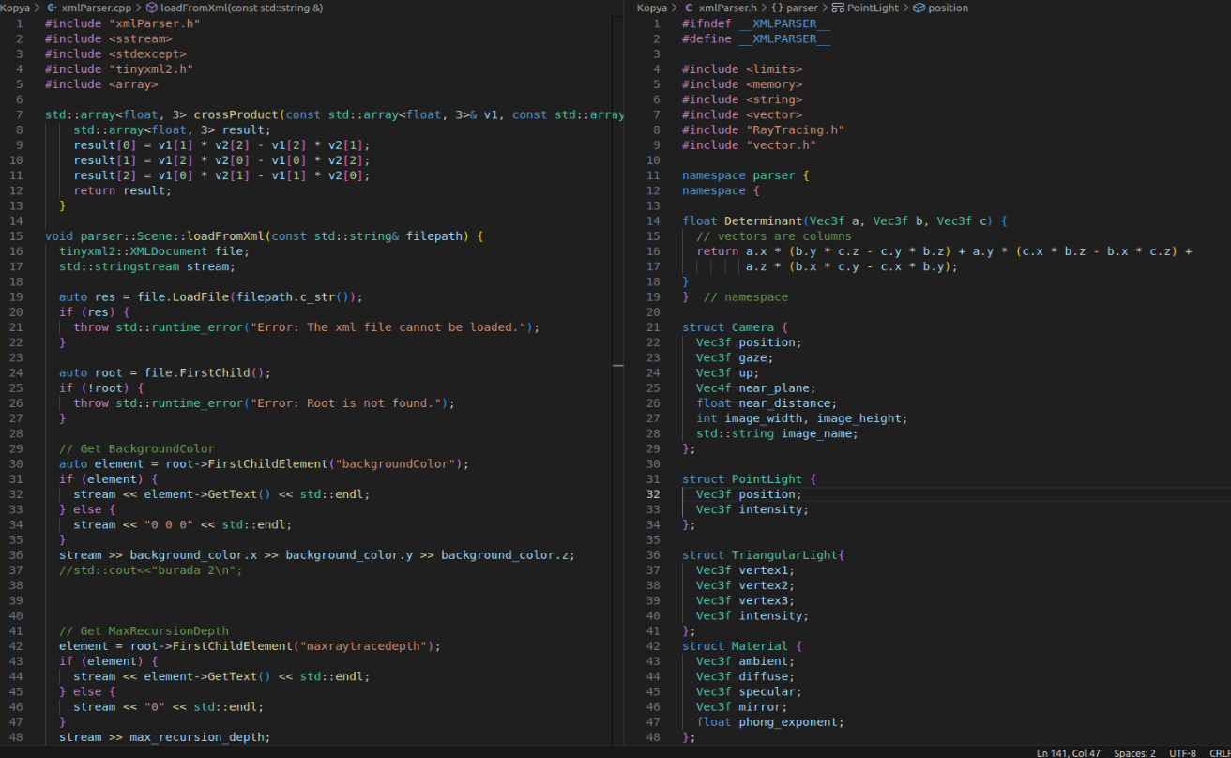

**2)Ray Tarcing**

The retrieved data is processed to perform the necessary calculations, and is then prepared to be output as an image in PPM format.

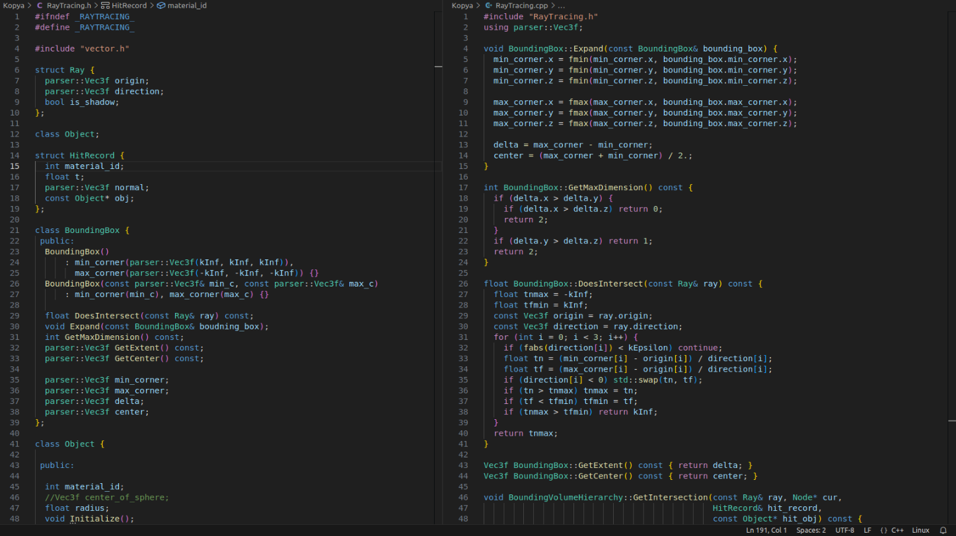

**3)** **Convert İmage PPM Format**

The created image array has been converted to PPM format using the convert function.

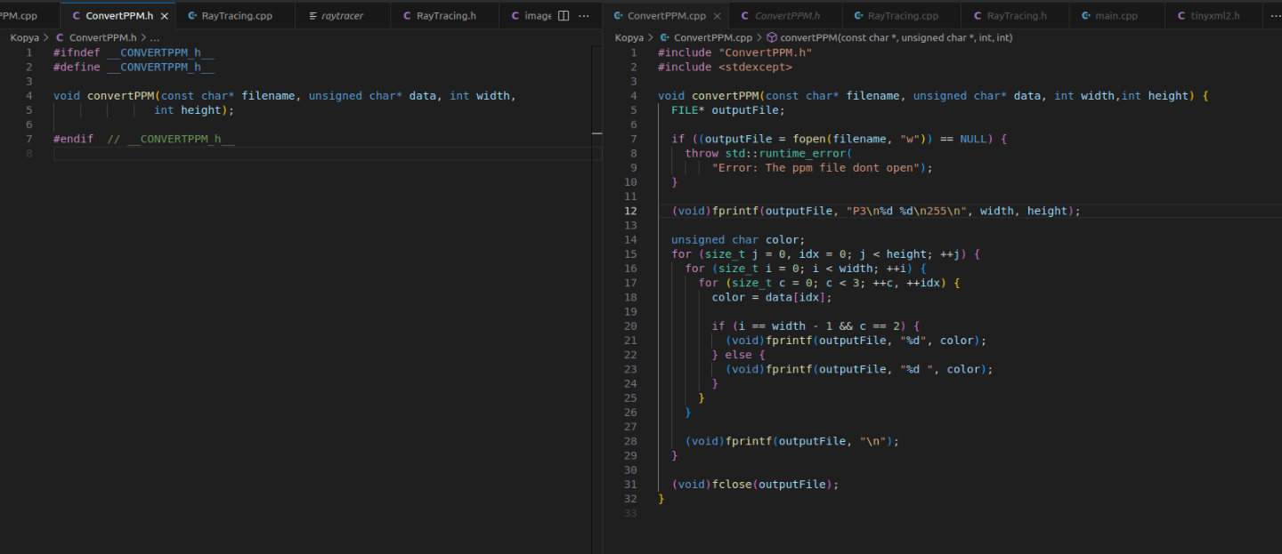

**3)Test**

The developed program has been tested with various XML files. Successful results have been obtained from the tests. Examples of the tests conducted are provided below.

**Example 1**

**Given input**

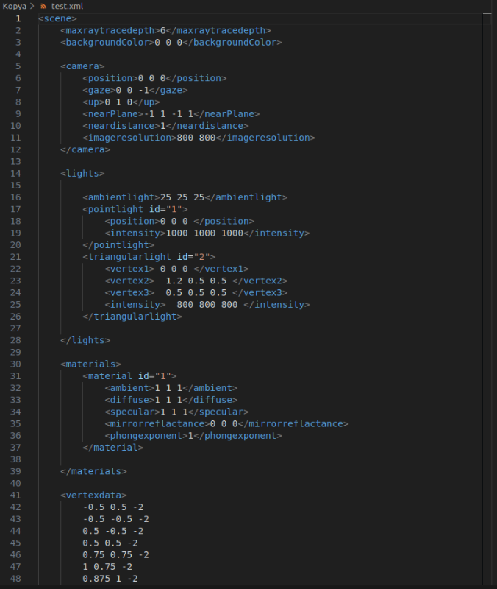

**Output**

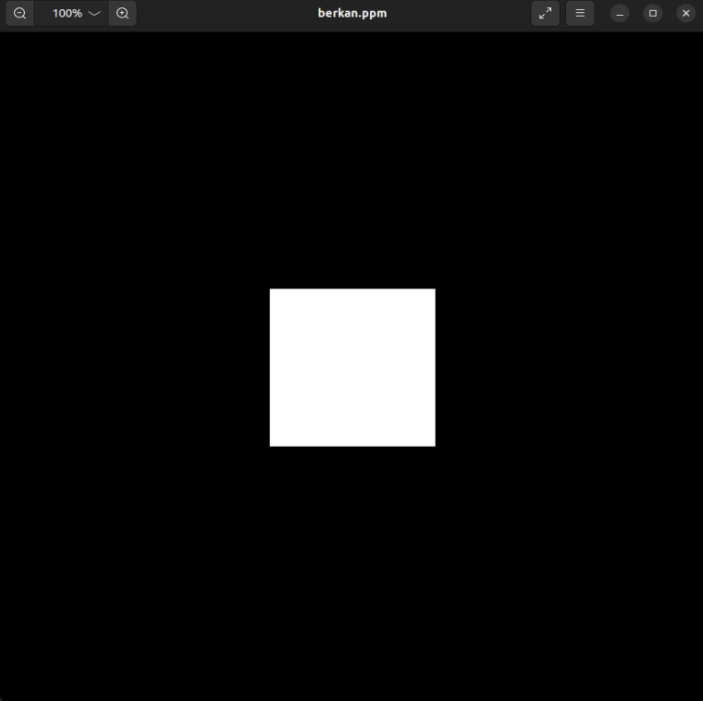

**Example 2**

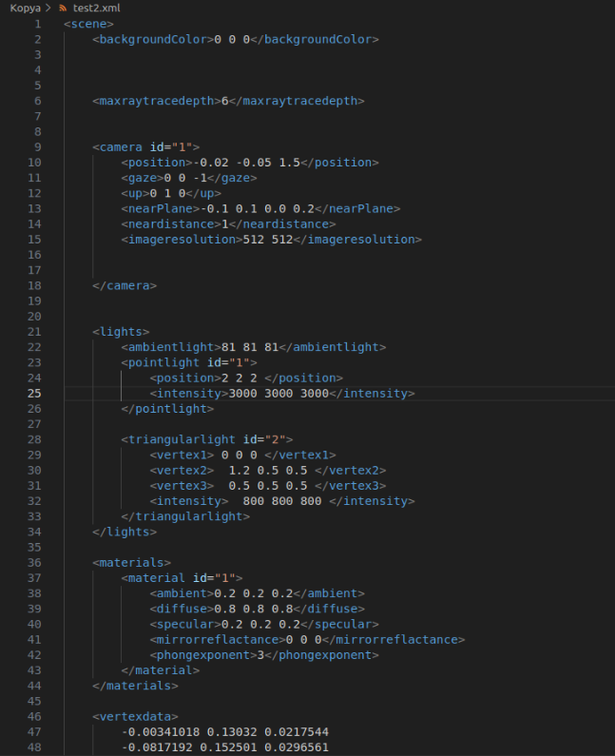

**Output**

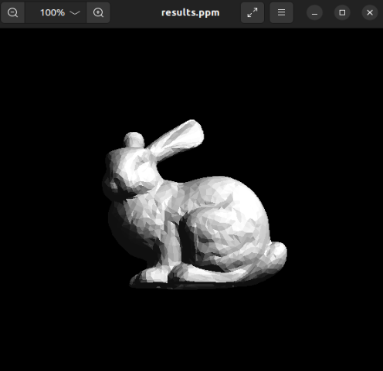

**4)** **Compilation and Execution**

You should run the makefile.

1. ./make

You should run the created raytracer file by providing it with an XML file.

1. ./raytaracer <xml file>